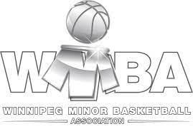

Winnipeg Minor Basketball Association: Central/NE Storm Registration

Athlete’s Name: _______________________________________________________
First Parent/Guardian’s Name: ___________________________________________
Second Parent/Guardian’s Name: ________________________________________
Birthdate (DD/MM/YYYY): _____________________

Have you played previously with any basketball clubs/leagues: YES NO
If yes, where? _____________________________________________________________
No. of Years Played: ___________

Please check off the following when completed:
- Copy of Birth Certificate
- Copy of Manitoba Health Card OR 6- and 9-Digit Numbers
- MASRC Registration Form

Note* Emails have been the quickest and easiest way to share information pertaining to our programs. Please check emails regularly while your player is playing in our program.

How did you hear about this program? _____________________________________________
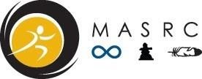
MASRC Sport Registration Form

Athlete Information

Name: ___________________________________________________ Gender: ____________
Birthdate: (MM/DD/YYYY): _____________
- First Nation
- Metis
- Non-Status Indigenous
- Inuit
- Other
If Other, what is the ethnic background of player (Optional): ______________________
Email: ____________________________________
Phone: _____________________ 6-Digit/ 9-Digit Health #_____________/_________________
Address: ________________________ City: __________________Postal Code: ___________
Allergies/ Medical Concerns: _____________________________________________________

______________________________________________________________________________________

Parent/ Guardian Information
Parent/Guardian #1 (Primary Contact):
Name: _______________________________________Relationship: _____________________
Email: _______________________________ Phone: _________________________________ Address: _________________________ City: ________________ Postal Code: ____________
Parent/Guardian #2 (Secondary Contact):
Name: _______________________________________Relationship: _____________________
Email: _______________________________ Phone: _________________________________
Address: _________________________ City: _________________ Postal Code: ___________

Parent/Guardian Name (please print):______________________________ Date: ___________
Signature: ___________________________________
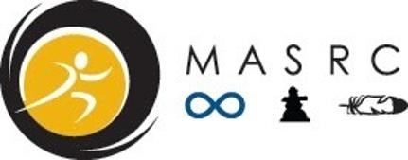

MASRC Media Release Form
By submitting and signing this form, I acknowledge the following:
I give Manitoba Aboriginal Sports & Recreation Council (MASRC) approval to record and edit my likeness, image, voice, interview, and performance. I agree that MASRC may use and authorize the use of any part of this documentation for, but not limited to, exhibition, publication, educational, and website purposes. This includes using the information by posting it on social media sites.
I also consent to MASRC releasing my name and community to representatives from media and community organizations for sponsorship purposes if needed.

Participant’s Name (please print): ________________________________________________
Parent/Guardian’s Name (please print): ____________________________________________
Signature: ________________________________ Date: ______________________________

MASRC Participant Consent
By submitting and signing this form, I acknowledge the following:
I give consent for the below mentioned player to be administered first aid and to be treated by an emergency medical technician, paramedic, nurse, or physician. Any follow up medical attention may be given at a local hospital and transportation to a local hospital in authorized. I hereby permit the below mentioned player to participate in the above mentioned program by giving my consent.

Participant’s Name (please print): ________________________________________________
Parent/Guardian’s Name (please print): _____________________________________________
Signature: ________________________________ Date: ______________________________

MASRC Waiver and Release of Liability
In consideration of being allowed to participate in any manner in the Manitoba Aboriginal Sports & Recreation Council’s athletic/sports program, related events and activities, the undersigned acknowledges, appreciates, and agrees that:
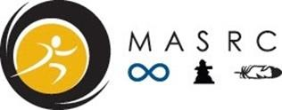
- The risk of injury from the activities involved in this program is possible, and while rules, equipment, and personal discipline may reduce this risk, the risk of injury does exist; and,
- I knowingly and freely assume all such risks, both known and unknown, even if arising from the negligence of the releases or others, and assume full responsibility for my participation; and,
- I willingly agree to comply with the stated and customary terms and conditions for participation. If however I observe any unusual significant hazard during my presence or participation, I will remove myself from participation and bring such to the attention of the nearest official immediately; and,
- I, for myself and on behalf of my heirs, assigns, personal representatives and next of kin, hereby release and hold harmless Manitoba Aboriginal Sports and Recreation Council, their officers, officials, agents, and/or employees, other participants, sponsoring agencies, sponsors, advertisers, and, if applicable, owners and leasers of premises used to conduct the event (“Releases”), with respect to any and all injury, disability, or loss or damage to person or property, whether caused by negligence or the releases or otherwise.

Participant’s Name (please print): _________________________________________________
Parent/Guardian’s Name (please print): _____________________________________________
Signature: ______________________________________ Date: _________________________

